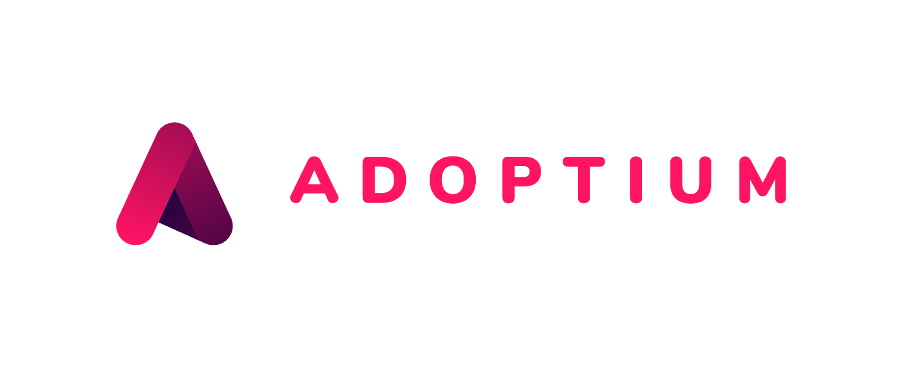
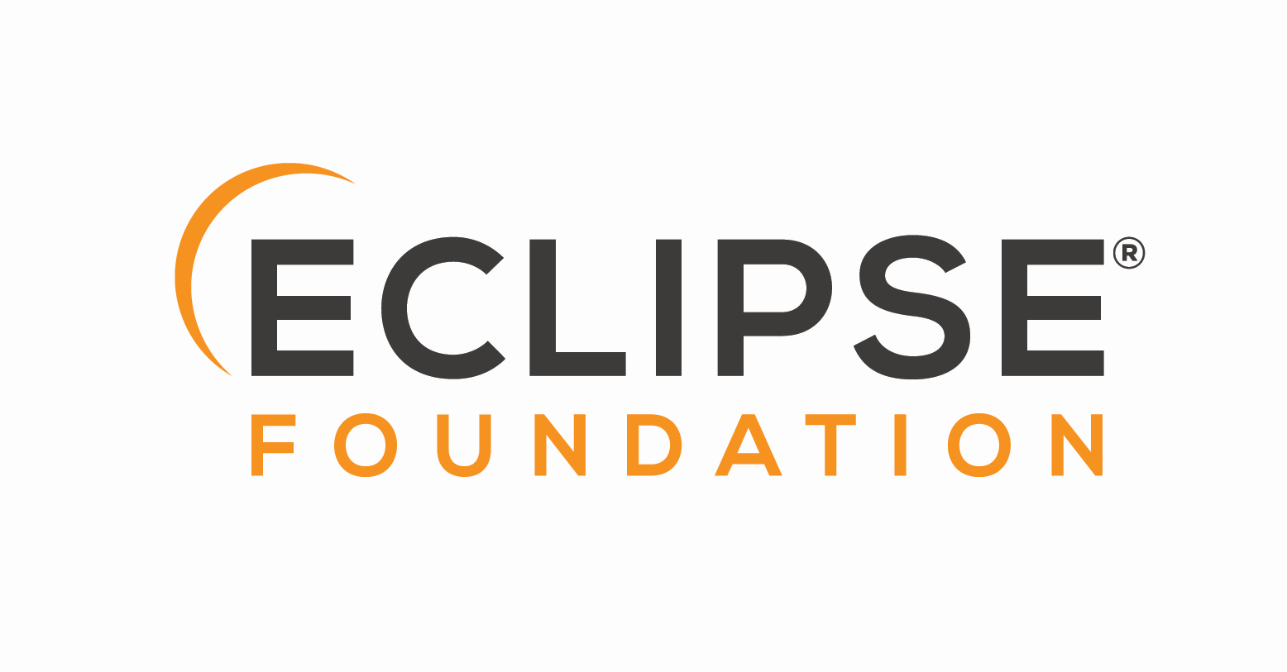

Adoptium
Project Management Committee
Agenda & Minutes

“The PMC as a whole, and the PMC leads in particular, are ultimately responsible for ensuring that the Eclipse Development Process is understood and followed by their Projects. The PMC is additionally responsible for maintaining the Top-Level Project’s charter.” [ref]

Date: 2026-July-15

Agenda:
- Approval of minutes or statements from the July 8, 2026 meeting.
- Review of outstanding actions.
- Review of GitHub issues and discussions flagged for PMC agenda
- AoB

Action items:
Date | Description | Status
None

Attendees
George Adams
Stewart Addison
Scott Fryer
Severin Gehwolf
Shelley Lambert
Andrew Leonard
San Hong Li
John Oliver
Martijn Verburg
Tim Ellison

Minutes:

Start time: 14:04

- The minutes from the July 8, 2026 meeting are approved.
- Review of outstanding actions. (None)
- Review of GitHub issues and discussions flagged for PMC agenda
  - Discussion on Discussion: Replacement Jenkins Server (https://github.com/adoptium/infrastructure/issues/4453)
  - Option 1 preferred (if finance committee can flush out budget details)
  - Plan to run both servers for a period of time (some overlap to allow us to fallback if we find its needed)
  - Timeline for trialing the new pipelines:
    - Ready for trialing some platforms for October release, so still release out of existing server.
    - Intend to fully transition release pipelines to the new server by January 2027 (barring any complications)
    - Other jobs on the current/old server may take time to assess and transition, so may be a later date for those to move (target by July 2027).
- AoB
  - July release update
    - Dry-runs launched and being triaged
    - Public side looks pretty good, need to check in with compliance team
    - TRSS updated to include remote server job status
    - New structure for triage issues is ‘noisy’ but purposeful, meant to separate triage activities to make it easier to assign to agents (coming in a next phase)
  - Semesters of Code 2 student teams update
    - Nearing end of term, student teams will create a presentation and record it
  - Adoptium Summit (Sept 29)
    - Consider what content you’d like to see, submit a talk or suggest topics in the PMC Slack channel and we can seek out speakers

End time: 14:29

